DNA sequencing is an important tool in the research and medicine fields, which can have a profound impact in areas such as caner, human genetics, infections diseases and personal genomics. There is currently a desire to lower the cost of DNA sequencing while simultaneously decreasing the time required for sequencing. The current state of DNA sequencing is largely based on imaging technology. This technology requires the interaction of light or x-rays with specialized nucleotides or other reagents. These requirements limit the advancement of sequencing, as light source machines are often bulky and expensive while specialize nucleotides and dyes deviate from nature.

One technology that consistently decreases in size and cost per unit area is CMOS technology, but how can a CMOS based chip be used? When a nucleotide is added to a fragment of DNA there is a release in hydrogen atoms, causing a shift in the pH of the surrounding fluid. If the change in pH was able to be detected then the event of a nucleotide being incorporated into a DNA strand could also be detected. A device known as an ion-sensitive field-effect transistor (ISFET) does exactly this [2].

An early version ISFET was composed of an oxide sensing layer along with a heavily doped drain and source located beneath. As hydrogen ions are released, interactions with the oxide-sensing layer causes protonation and deprotonation of the OH groups.

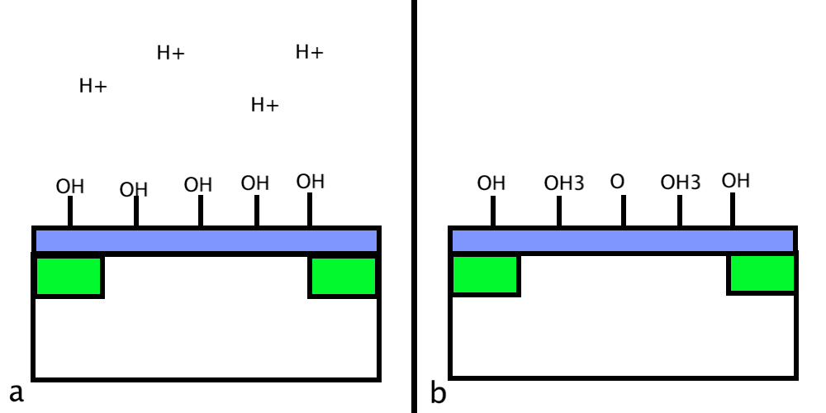

Figure 1 | Oxide Sensing Layer. a. Arrangement of OH groups on oxide-sensing layer before interaction with hydrogen ions. b. Charge accumulation on the oxide-sensing layer after protonation and deprotonation of OH groups.

After the hydrogen bonds interact with the OH groups there is a build up of charge on the oxide-sensing layer. This build up of charge acts similar to the gate voltage of a MOSFET device, enabling a conductive band to be formed between the drain and source allowing current to flow.

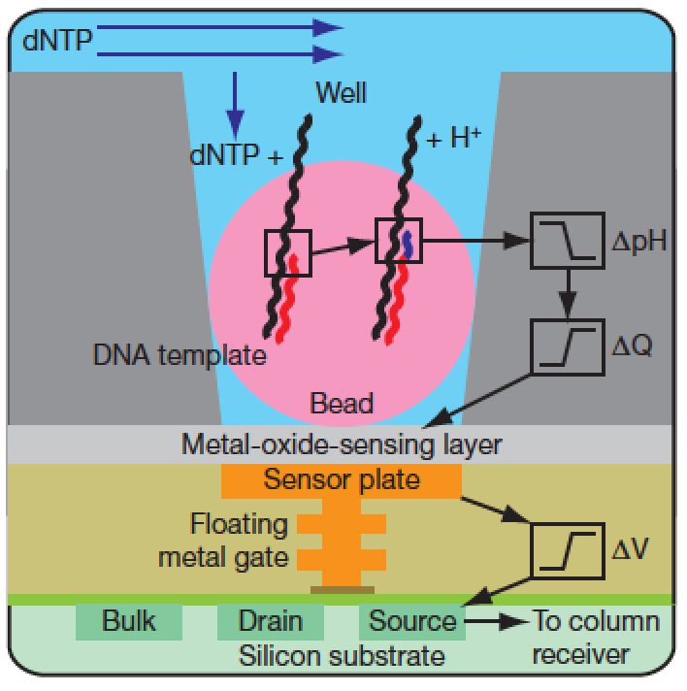

Figure 2 | ISFET device layout. Simplified drawing of a well, a bead containing DNA and the underlying sensor.

The device presented in this paper is a very large array of ISFETs (Fig. 2) arranged in a two dimensional x andy y pattern. Individual sensors are read with a technique similar to CMOS imagers. Samples are kept stationary by trapping the bead containing the DNA template in a 3.5um-diameter well. At the bottom of each well tantalum oxide provides the sensing surface to detect hydrogen ions. Unlike imaging technology, which gathers many small bits of information to reconstruct the whole picture, each sensor is capable of detecting the nucleotide incorporation event.

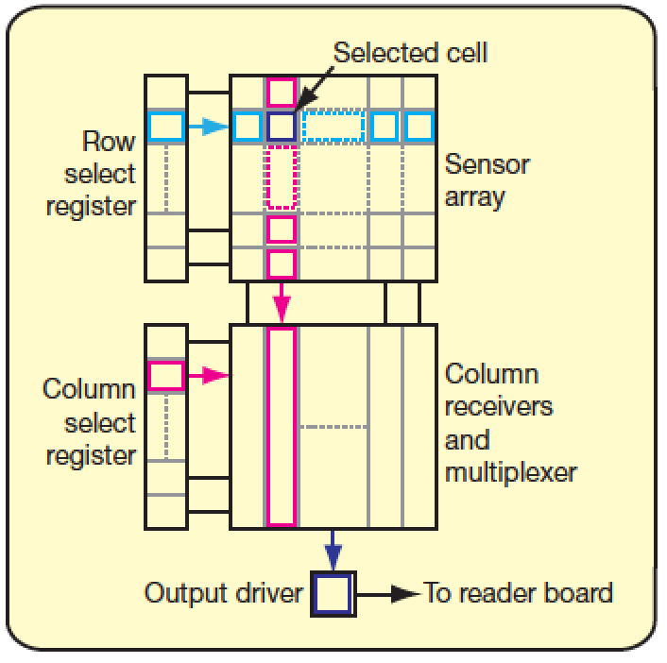

Figure 3 | Sensor layout. Each sensor is indexed through a row select register followed by a column select register.

Although not stated specifically the technology used to address each of the sensors is most likely a charge-coupled device which is able to shift charge from one location to another. These devices are very well studied and compatible with CMOS fabrication so their implementation would not have been an issue. One alternative to reading the sensor values independently would be to “collect” all the charge present on the device and use this total charge to identify nucleotide incorporation. This would average out the results from all the sensors and reduce the amount of computation required.

One limitation that is evident is the size of the sensor is constrained to the size of the 3.5um bead. An ISFET can be fabricated with a smaller footprint that the bead so if there was a way to eliminate the need for the bead these devices could become more dense. One possible improvement would be to use a smaller bead with a smaller well however there would be a limit as the beads must remain in the well during each flow cycle of nucleotides. As the bead size decreases the well depth would have to decrease to ensure only one bead enters the well at a time. When the well depth becomes to shallow the bead would be flushed out.

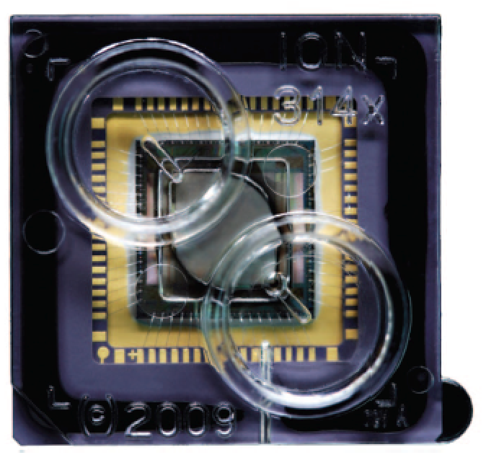

Figure 4 | ION Chip. Sensor array wire bonded for electrical connection and encased in polycarbonate flow cell

The chips were fabricated on an 8” silicon wafer, then cut apart and robotically packaged in a disposable polycarbonate flow cell (Fig. 4). The flow cell serves two purposes, to ensure the fluids remain in contact with the sensor array and protect the surrounding electronics from the fluid.

There were three different chips used, each with a different number of sensor elements (1.5M, 7.2M, 13M). Increasing the number of sensors per chip was accomplished by increasing the chip size. In each of the cases all of the devices were not able to be used. The tear drop shape of the flow cell prevents the corners of the device normal to the flow of fluid from being utilized so the number of active sensors is reduced to 1.2 M, 6.1 M, 11 M. It was shown that an even more dense chip is possible by using 1.3 um wells with a 110 nm CMOS node size as shown in Figure 5. One problem with decreasing the sensor size is the signal to noise ratio will worsen which may lead to a decrease in system accuracy.

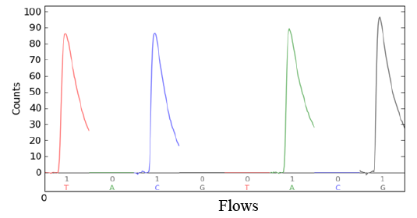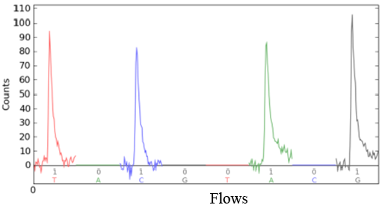

Figure 5 | 3.5 um and 1.5 um Well Signals. a. 3.5 um well nucleotide sequencing signal per sensor. b. 1.5 um well nucleotide sequencing signal per sensor.

a

b

To use the device DNA is first fragmented, ligate to adapters, and adaptor-ligated libraries are clonally amplified onto beads. The sequencing primers and DNA polymerase are then loaded into the chip via pipette. Beads are “seated” into the wells by spinning the chip with a commercial desktop centrifuge. Nucleotides are then added in a step wise fashion during an automated run. After nucleotide is introduced the signals form the sensors are recorded as shown in Figure 6. A four second pause is taken after each nucleotide is added to allow the signal to be collected, the system to return to normal and a decision to be made about the incorporation of the nucleotide. Then a rinse cycle is initiated which washes any remaining nucleotides in the wells which through diffusion takes approximately one tenth of a second.

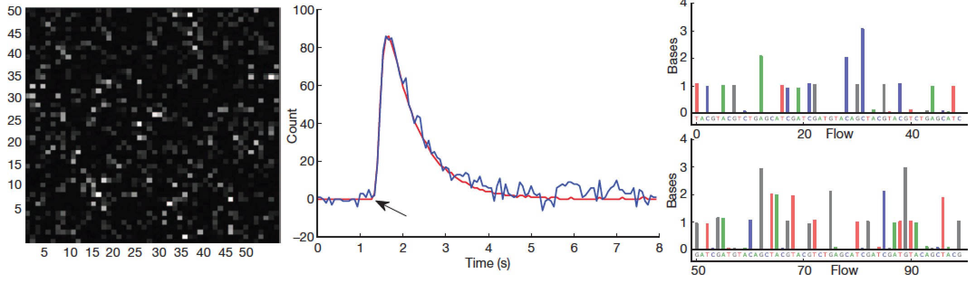

Figure 6 | Nucleotide sensing. a. 50x50 region of ION chip displaying the count intensities of each sensor. b. Count signal from a single ISFET sensor

a

b

One thing that is not mentioned in this paper is the meaning of the word “count”. It is most likely that “count” is a measure of the intensity of the change in pH for a particular sensor. With the incorporation of a single nucleotide, it is stated that, there would be a 0.02 shift in the pH of the well so perhaps “count” is a measurement of these pH shifts. If this were the case then “count” could also indicate when multiple nucleotides of the same base were incorporated during a single run.

A problem that is evident in Figure 6.a is that when a nucleotide is added to the chip not all wells will respond with the same intensity. This may be due to ISFET degradation. When an ISFET interacts with ions it is sensitive to it is impossible to fully return it to its previous state. As more and more runs are done on the device the quality of signal produced would degrade. These ion chips combat this through the shear number of devices present on a chip. This means that the trend of the entire chip is measured instead of relying on a single device which could be quite inaccurate.

Overall this seems to be a viable technology as they were able to sequence three bacterial genomes from 5-fold to 10-fold covering 96.80% to 99.99% of the genome. The system was also used to sequence an individuals DNA (G. Moore) with approximately 10-fold coverage. This system is semi-scalable as there seems to be a fundamental lower limit to the well sizes, however it is simply possible to increase the size of the die to increase throughput.

References:

1. J. M. Rothberg, W. Hinz, T. M. Rearick, J. Schultz, W. Mileski, M. Davey, J. H. Leamon, K. Johnson, M. J. Milgrew, M. Edwards, J. Hoon, J. F. Simons, D. Marran, J. W. Myers, J. F. Davidson, A. Branting, J. R. Nobile, B. P. Puc, D. Light, T. a Clark, M. Huber, J. T. Branciforte, I. B. Stoner, S. E. Cawley, M. Lyons, Y. Fu, N. Homer, M. Sedova, X. Miao, B. Reed, J. Sabina, E. Feierstein, M. Schorn, M. Alanjary, E. Dimalanta, D. Dressman, R. Kasinskas, T. Sokolsky, J. a Fidanza, E. Namsaraev, K. J. McKernan, A. Williams, G. T. Roth, and J. Bustillo, “An integrated semiconductor device enabling non-optical genome sequencing.,” Nature, vol. 475, no. 7356, pp. 348–352, Jul. 2011.
2. M. Handel, “Short communications.,” J. Exp. Biol., vol. 216, no. Pt 10, p. 1757, May 2013.
3. C.-S. Lee, S. K. Kim, and M. Kim, “Ion-sensitive field-effect transistor for biological sensing.,” Sensors (Basel)., vol. 9, no. 9, pp. 7111–31, Jan. 2009.
4. T. Sakurait and Y. Husimi, “Real-Time Monitoring of,” no. 3, pp. 1996–1997, 1997.